# Lab 2. Task 1- preparation task Template for answers

**Save this document as a .pdf document before submitting.**

*Student names and LiU-IDs: (Max 2 students per group):*

*1. Cindy Khuong (cinkh090)*

*2. Rebecca Sjödin (rebsj192)*

*Submission date: 21-11-23*

*Version (in case you need to re-submit): 2*

## **Testing different box filters**

**1)** Image1:

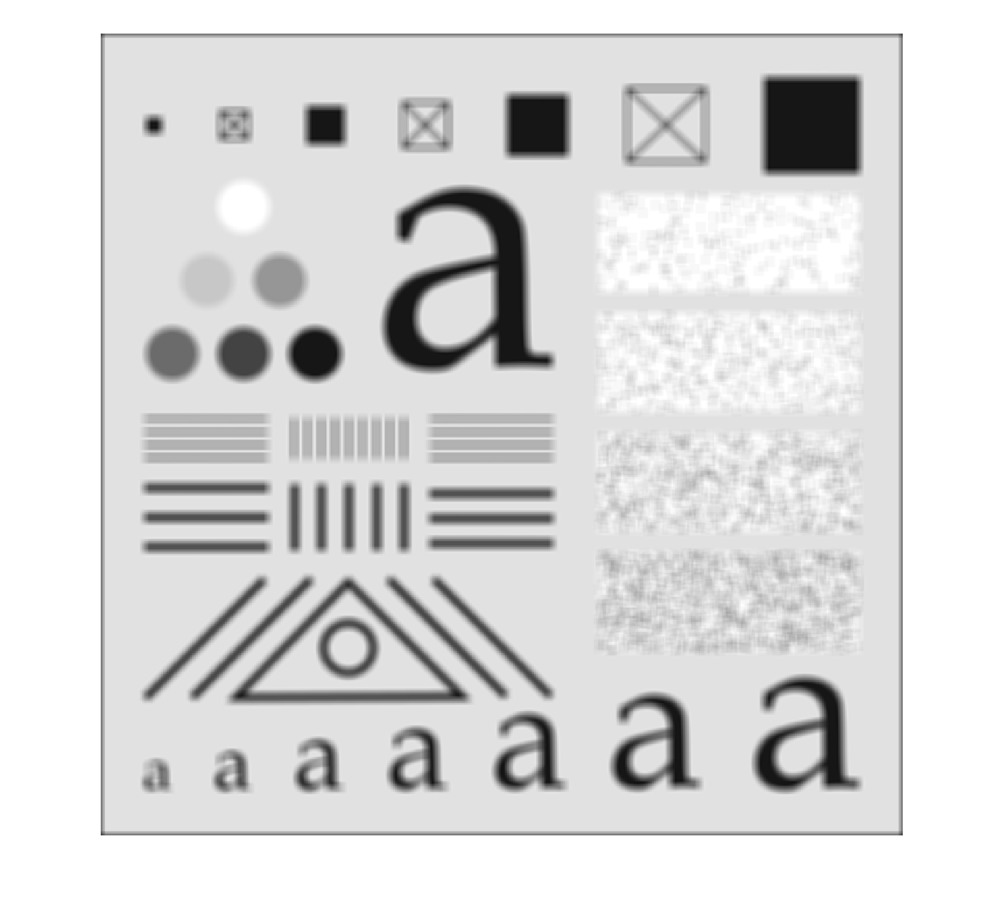

**2)** Image2:

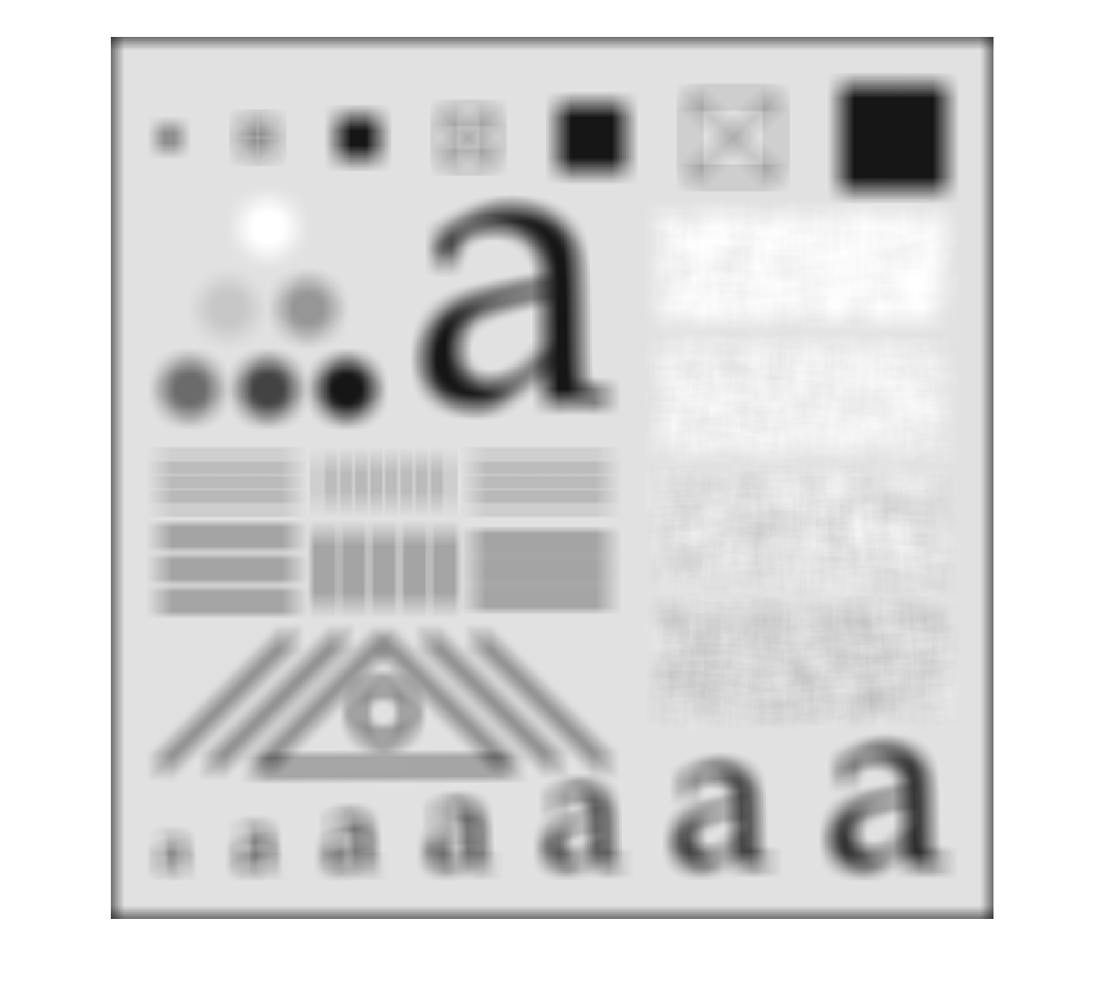

**3)** Does the box filter have a lower or higher cutoff frequency than the box filter? Explain why!

When we increased the box filter to 21 x 21 we received a more blurred image. Therefore the 21 x 21 box filter has a lower cutoff frequency and that is because it eliminates more of the higher frequencies. The image loses more information.

**4)** What is the reason for these dark borders in Image2?

Because we have a zero padding. The imfilter function fills the pixels on the edge with black because they have the pixel value = 0. The size of the dark border depends o the size and type of the filter kernel used.

**5)** Image3:

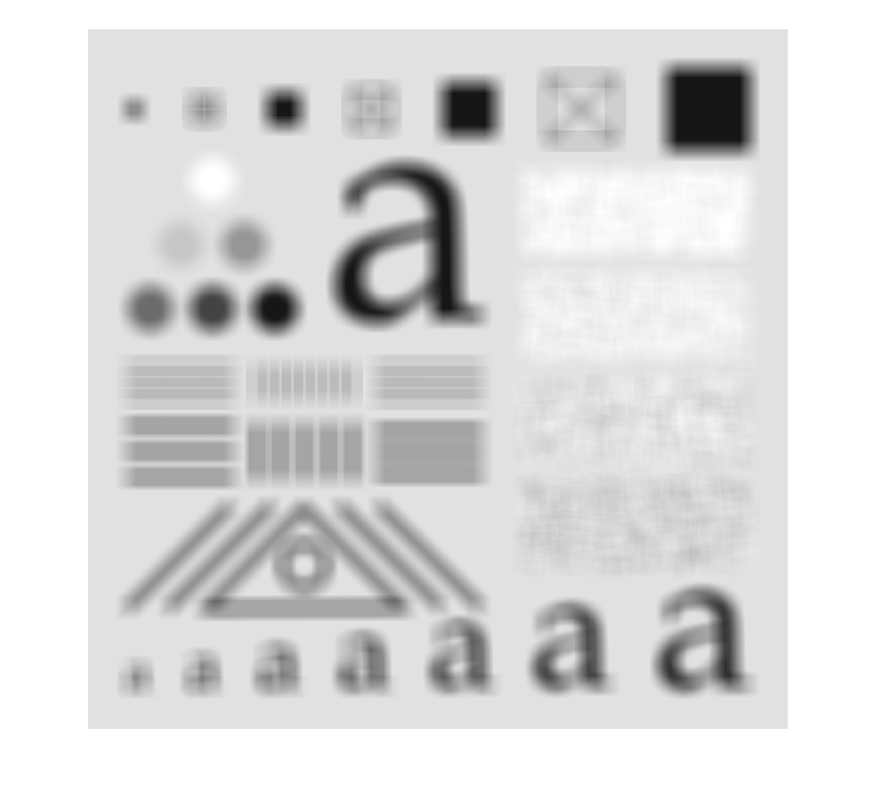

**6)** Image4:

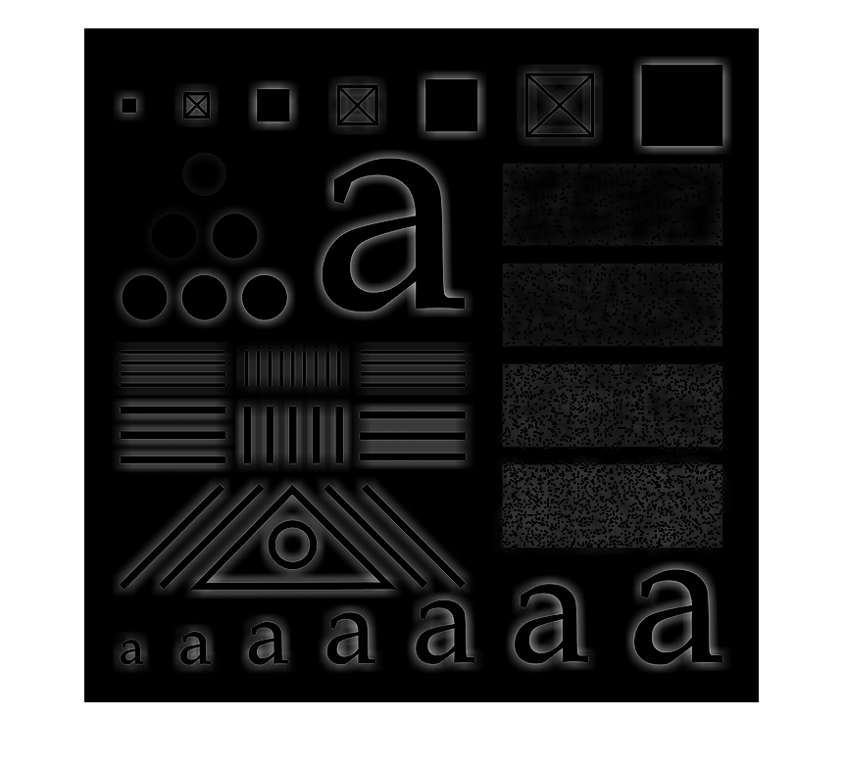

**7)** Why is so dark? What is the average value of the pixel values in ? And why?

The image is dark because most of the pixels has a negative value. Because it is a highpass filter only the high frequencies get trough and the low frequencies are rejected.

Because we are subtracting a lowpass function from 1 (mean value) we get negative values.

A highpass filter kernel is obtained by subtracting a lowpass filter kernel from a unit impulse with the same center as the kernel. Because they have the same center the mean value will become zero when subtracting the lowpass filter.

**8)** Image5:

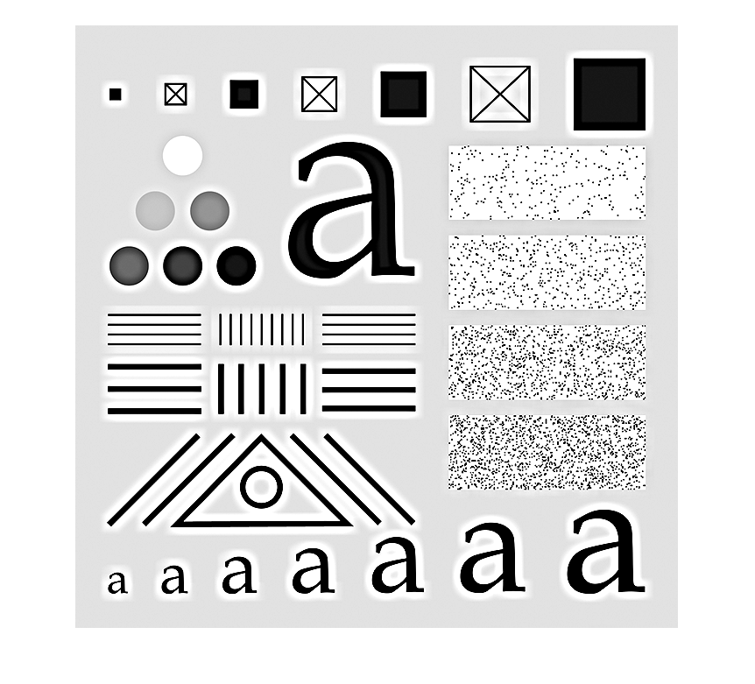

## **Testing Sobel filter kernels and gradient**

**9)** Image6:

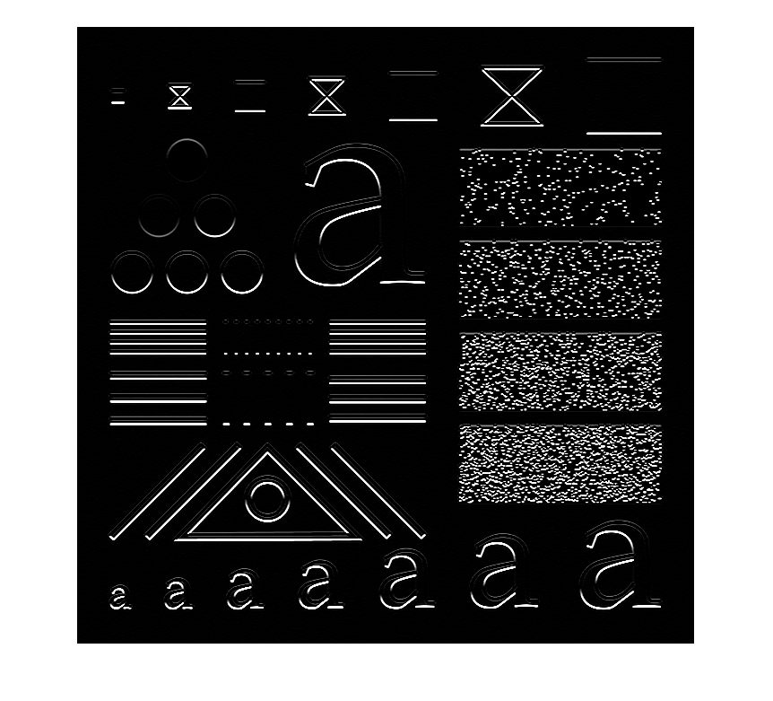

**10)** Image7:

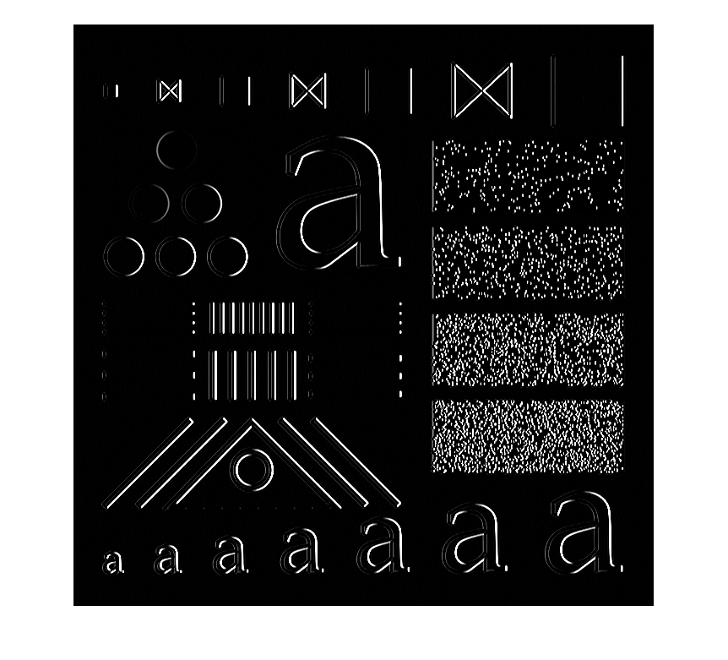

**11)** Image8:

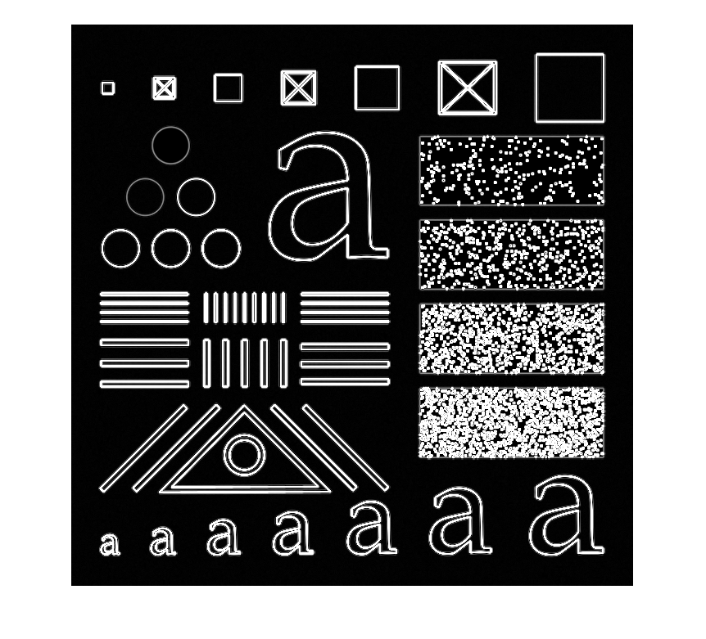

*Don’t forget to save the document as* ***.pdf*** *before submitting!*